|  |
| --- |
|  |
| Capstone Project Document |

**Hotel Booking System**

Report #2 – Project Plan

|  |  |  |
| --- | --- | --- |
| **COD Team** | | |
| **Group Members** | Trần Huy Duẫn | SE03268 |
| Nguyễn Thị Lan Phương | SE03168 |
| Nguyễn Hữu Nhật | SE03180 |
| Nguyễn Hải Lý | SE03391 |
| Hoàng Đình Cường | SE03326 |
| **Supervisor** | Mr. Đào Trọng Duy | |
| **Project code** | HBS | |

**- Hanoi, 09/2016 –**

# SIGNATURE PAGE

AUTHOR: Nguyễn Thị Lan Phương 12/09/2016

Team member

REVIEWERS: Trần Huy Duẫn --/09/2016

Project Manager

APPROVAL: Đào Trọng Duy --/09/2016

Supervisor

Record of change

*A - Added M - Modified D – Deleted

|  |  |  |  |  |  |
| --- | --- | --- | --- | --- | --- |
| Effective Date | Changed Item | A,M,D | Change Description | Reason for Change | Rev. Number |
| 12/09/2016 | Introduction, Project Overview | A | Create Introduction, Project Overview | First version | 1.0 |
| 13/09/2016 | Project Development Approach, Estimation (Size) | A | Create Project Development Approach, Estimation (Size) | First version | 1.0 |
| 14/09/2016 | Estimate (Effort, Schedule, Resource, Infrastructure, Training Plan, Finance) | A | Create Estimate (Effort, Schedule, Resource, Infrastructure, Training Plan, Finance) | First version | 1.0 |
| 15/09/2016 | Project Organization, Communication & Reporting, Configuration Management | A | Create Project Organization, Communication & Reporting, Configuration Management | First version | 1.0 |
| 21/09/2016 | Estimate (Effort, Schedule) | A | Modify Estimate (Effort, Schedule) | First version | 1.0 |
|  |  |  |  |  |  |

**Contents**

SIGNATURE PAGE 1

1 INTRODUCTION 2

1.1 Purpose 2

1.2 Acronyms and Definitions 2

2 PROJECT OVERVIEW 3

2.1 Project Description 3

2.2 Scope and Purpose 3

2.2.1 Purpose of Project 3

2.2.2 Scope of Project 4

2.2.3 The Functions of Project 4

2.3 Assumptions and Constraints 4

2.4 Project Objectives 5

2.4.1 Standard Objective 5

2.4.2 Specific Objectives 6

2.5 Critical Dependencies 6

2.6 Project Risk 6

3 PROJECT DEVELOPMENT APPROACH 7

3.1 Project Process 7

3.2 Requirement Change Management 8

3.3 Quality Management 8

3.3.1 Defect Prevention Strategy 8

3.3.2 Review Strategy 9

3.3.3 Unit Testing Strategy 10

3.3.4 Integration Testing Strategy 10

3.3.5 System Testing Strategy 11

3.3.6 Estimates of Defects to be detected 11

3.3.7 Measurements Program 11

4 ESTIMATION 12

4.1 Size 12

4.2 Effort 12

4.3 Schedule 12

4.3.1 Project Milestone 12

4.3.2 Activity Schedule 13

4.4 Resource 14

4.5 Infrastructure 14

4.6 Training Plan 15

4.7 Finance 16

5 PROJECT ORGANIZATION 17

5.1 Organization Structure 17

5.2 Project Team 18

5.3 External Interfaces 19

6 COMMUNICATION & REPORTING 19

7 CONFIGURATION MANAGEMENT 21

# INtroduction

## Purpose

This part is the project management plan of Hotel Booking System (HBS) Project – our Capstone Project in FPT University. It is included the project overview, project organization, tools and infrastructures, schedule of this project.

## Acronyms and Definitions

|  |  |
| --- | --- |
| Acronym & Abbreviation | Definition |
| HBS | Hotel Booking System |
| QA | Quality Assurance Officer |
| PM | Project Manager |
| SPMP | Software Project Management Plan |
| SRS | Software Requirements Specifications |
| SDD | Software Design Description |
| STD | Software Test Documentation |
| SUM | SoftwareUser’s Manual |
| CC | Infrastructure Configuration Controller |

Table ‑: Definitions and Acronyms

# Project overview

## Project Description

|  |  |  |  |
| --- | --- | --- | --- |
| Project Code | HBS | Contract Type | None |
| Customer | Vietnamese | 2nd Customer | None |
| Project Level | Group | Project Rank | None |
| Application Type | Website | Project Manager | Trần Huy Duẫn |
| Project Category | Development | Business Domain | Service |

Table ‑: Project Description

## Scope and Purpose

### Purpose of Project

This project is a capstone project of our group at FPT University. However, we want to create a website not only we can pass capstone project but also we want it really useful for user.

In study process, we used different hotel booking website see that have a lots inadequacy. So, our website is created with purpose to the most convenient for user. For example, the website supports searching function from budget hotel to luxury hotel around destination by district, service... User can give individual's feedback about that hotel. In addition, the website also supports direction from user's location to hotel and supports to search the vicinity of hotel based on user's current position. Hotel manager can perform functions related to booking, request, contribute request and view reports by conditions and for admin can manage all of functions and data of system.

During 4 months of capstone project, we hope that all member can get more knowledge about processing of software development, skill do document, coding, testing. Moreover, soft skill also very important, we can get skill management time, working in group, skill communication… It is not long time for project but our group hope that can do this project successfully.

### Scope of Project

The scope of this project contains: Requirement Analysis, Design, Coding and Testing (Unit Test, Integration Test, System Test).

### The Functions of Project

References to HBS_Introduction_v1.3_EN.

## Assumptions and Constraints

|  |  |  |
| --- | --- | --- |
| **No** | **Description** | **Note** |
| **Assumptions** | | |
| 1 | Customer reviewers will get seven days to approve a milestone document. If no comments are received within this time period, it will be considered as approved. |  |
| **Constraints** | | |
| 1 | This project must be completed and delivered before 07/12/2016 | Schedule |
| 2 | In doing project processing, PM must submit report (include 6 reports) on certain date. | Schedule |
| 3 | Software Requirement Specification Document and Project Plan must be completed within 7 days since 05/09/2016  **Deadline**:12/09/2016 | Schedule |
| 4 | Design Document (include Architecture Design, Screen Design, Database Design) must be completed within 14 days since 13/09/2016  **Deadline**: 26/09/2016 | Schedule |
| 5 | Integration Test (include test plan and test case…) must be completed within 14 days since 27/09/2016  **Deadline:** 10/10/2016 | Schedule |
| 6 | Completed coding activity and have unit test result within 40 days since 28/09/2016  **Deadline:** 07/11/2016 | Schedule |
| 8 | Deliver report about User manual, software package and installation guide on 5 days since 01/12/2016  **Deadline**: 05/12/2016 | Schedule |
| 9 | Complete all of document and application before finishingtheprojecton07/12/2016 | Schedule |
| 10 | Project contains 5 members | Resource |

Table ‑: Assumptions and Constraints

## Project Objectives

### Standard Objective

|  |  |  |  |  |
| --- | --- | --- | --- | --- |
| Metrics | Unit | Committed | Re-committed | Note |
| Start Date |  | 05/09/2016 |  |  |
| End Date |  | 07/12/2016 |  |  |
| Duration | Day | 94 |  |  |
| Team Size | Person | 5 |  |  |
| Billable Effort | Person-day | 470 |  | 1 Person-day = 5 hours |
| Calendar effort | Person-day | 470 |  | 1 Person-day = 5 hours |
| Effort Usage | % | 100 |  | 1 Person-day = 5 hours |

Table ‑: Standard Objective 1

|  |  |  |
| --- | --- | --- |
| Metrics | Unit | Basic for setting Goals |
| **Average** |
| Customer Satisfaction | Point | 9 |
| Leakage | Wdef/mm | 4 |
| Effort Efficiency | % | 90 |
| Timeliness | % | 100 |

Table ‑: Standard Objective 2

### Specific Objectives

|  |  |  |  |
| --- | --- | --- | --- |
| Metrics | Unit | Basic for setting Goals | |
| **Plan** | **Actual** |
| Training technology: ASP.net, Bootstrap, MVC, Github, Muckup, jQuery ajax | Person-day | 15 | 15 |
| Execute group review | Person-day | 8 | 7 |
| Training requirements, process before coding | Person-day | 8 | 7 |

Table ‑: Specific Objectives

### Critical Dependencies

|  |  |  |  |
| --- | --- | --- | --- |
| No | Dependency | Expected delivery date | Note |
| 1 | Project Plan and SRS must be completed and delivered to Supervisor | 30/09/2016 |  |
| 2 | User manual, Software Package and Installation Guide must be completed and delivered to Supervisor and FPT University. | 05/12/2016 |  |

Table ‑: Critical Dependencies

## Project Risk

PM identifies risks in the Risk Management Plan. The document is updated to trigger each milestone, each event also. The document is updated weekly by the PM, Risk Management Plan will be notified to all of the stakeholders affected. Status of risk is reported to supervisor at Project Milestones Report.

Reference to HBS_Risk Management Plan_v1.0_EN.xlsx.

# PROJECT DEVELOPMENT APPROACH

## Project Process

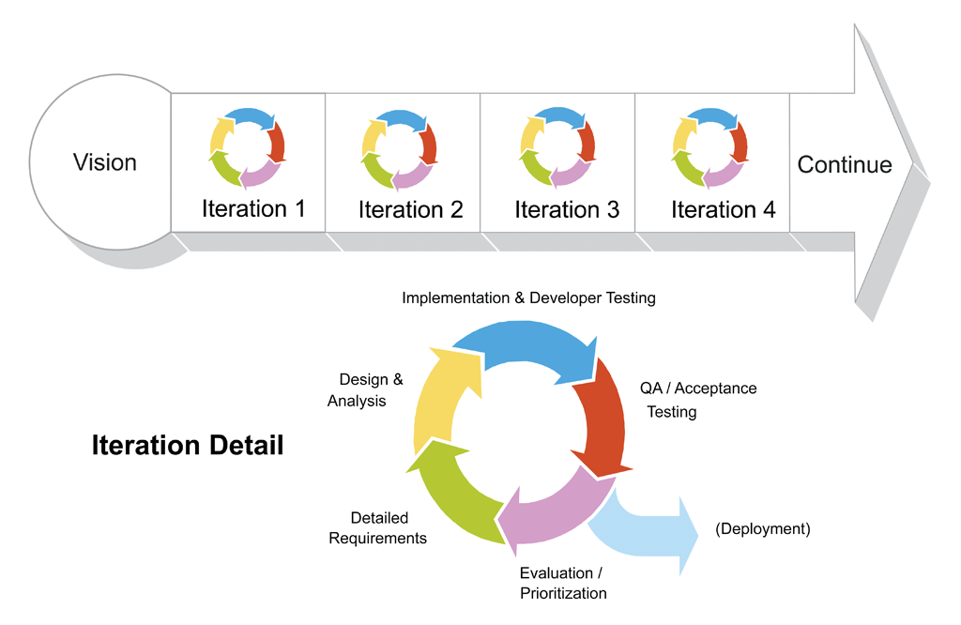

Figure 3‑1: Iterative and Incremental software process model

This figure above describes the information and products flow lifecycle process model. Sharing trip project uses the iterative and incremental software process model.

Iterative and incremental software development is a method of software development that is modeled around a gradual increase in feature additions and a cyclical release and upgrade pattern.

We choose “The Iterative and Incremental Software Process Model” because it’s most use when the scope of the project is big, the major requirements were defined clearly, some more detail will be added in time, and for the newbie group in software development. By using this software process model, we need a clear and completely planning and design of whole system.

To customer can use, each version must be implemented as a full process from Preliminary investigation, analysis, design, coding, testing, implementation, maintenance that is seen as a child cycle and each this child cycle is a small waterfall process. But because of time constraint, each cycle, we only focus on 4 phases: analysis, design, coding, testing. The objectives of first version are development of core and group of important functions. After each version that was put into to use, the results of evaluation will be feedback and planed for the next version.

The project team can learn from first iterations and may use best practices and experiences in next iterations.

In the project we have two cycles:

• Cycle 1: Start 05/09/2016 to 05/11/2016. In this iterative we will to analyze, design, coding, and testing the main feature of project.

• Cycle 2: Start 06/11/2016 to 05/12/2016. In this iterative we will to fix bug in iterative 1, complete other features, test again and packing product.

Thus, iterative and incremental development model helps to reach project goals in the most efficient way.

## Requirement Change Management

|  |  |
| --- | --- |
| **Who logs the change request?** | Any team members |
| **Who reviews the change request?** | PM or who is PM assign |
| **Who approves the change request?** | PM by default, if:   * Changes to project scope * Changes in delivery plan of project deliverable   Changes to assignment for key roles (PM) |

Table ‑: Requirement Change Management

## Quality Management

### Defect Prevention Strategy

|  |  |  |
| --- | --- | --- |
| Item (Process/Product) | Strategy | Expected Benefits |
| Requirement missing | List up all of requirement into Requirement Management Specification document. | 10–20% reduction in defect injection rate and about 2% improvement in productivity |
| Careless mistake in Design Document Format/Template wrong | After designing, QA will review Document Format base on checklist review design | Improvement in quality as overall defect removal efficiency will improve; some benefits in productivity as defects will be detected early |
| Use wrong template | Have a meeting to disseminate all template that is used in this project for all member | All member will use right template when do document |
| Coding application does not match with User Requirement. | Develop team must study about requirement/design within 1 weeks since project is assigned.  PM has responsibility to review task results and explain User Requirement for develop team PM has responsibility to review task results and explain User Requirement for Develop Team | Coding Application match with User Requirement. |

Table ‑: Defect Prevention Strategy

### Review Strategy

|  |  |  |  |  |
| --- | --- | --- | --- | --- |
| Review Item | Reviewer | Review Type | Review Method | Completion Criteria |
| Project Plan  Project Schedule  CM Plan | PM, QA, Supervisor | Group review  Group review  One-person review | Use checklist and Self-review |  |
| Business analysis and requirements specification document, Use Case catalog | PM, QA, Supervisor | Group review and One-person review | Use checklist |  |
| Design document, object model | Self-review, PM, QA, Supervisor | One-person Review | Use checklist |  |
| Stage plans | PM, QA, Supervisor | One-person review | Use checklist |  |
| Complex/first time generated program specs incl. test cases, interactive diagrams |  | Group review |  |  |
| Source code | Self-review, Peer review, PM, Supervisor | One-person review and Group review | Self-review and use checklist |  |

Table ‑: Review Strategy

### Unit Testing Strategy

|  |  |  |  |  |
| --- | --- | --- | --- | --- |
| Item to be Unit Tested | Unit Test Type | Unit Test Technique | Tool Used | Unit Test Completion Criteria |
| Source Code | White-Box Test | Using unit test case and test script | None | - Number of UTC/KLOC: 70 UTC/KLOC  - Number defects/KLOC: 18 defects/KLOC  - Statement coverage: 100%  - Branch coverage: 100%  - Path coverage: 100% |

Table ‑: Unit Testing Strategy

### Integration Testing Strategy

|  |  |  |  |  |
| --- | --- | --- | --- | --- |
| Item to be Integration Tested | Integration Test Type | Integration Test Technique | Tool Used | Completion Criteria |
| Do test by flow of functions and items which have concern each other | Black-Box Test |  | Checklist, Boundary | - Number of UTC/KLOC: 70  - Number of defects/KLOC: 18 |

Table ‑: Integration Testing Strategy

### System Testing Strategy

|  |  |  |  |  |
| --- | --- | --- | --- | --- |
| Item to be System Tested | System Test Type | System Test Technique | Tool Used | Completion Criteria |
| Test whole system | Black-Box Test |  | None | -Number of UTC/KLOC: 70  -Number of defects/KLOC: 18 |

Table ‑: System Testing Strategy

### Estimates of Defects to be detected

|  |  |  |  |
| --- | --- | --- | --- |
| **Review/Testing Stage** | **Targeted No. of Defects to be detected** | **% of Defects to be detected** | **Basic for Estimation** |
| **Requirements review** | 10 | 6.25% | Referenced to similar project estimations |
| **Design review** | 16 | 10% | Referenced to similar project estimations |
| **Code review** | 80 | 50% | Referenced to similar project estimations |
| **Unit Test** | 18 | 11.25% | Referenced to similar project estimations |
| **Integration Test** | 18 | 11.25.8% | Referenced to similar project estimations |
| **System Test** | 18 | 11.25% | Referenced to similar project estimations |
| **Total** | 160 | 100% |  |

Table ‑: Estimates of Defects to be detected

### Measurements Program

|  |  |  |  |
| --- | --- | --- | --- |
| Data to be collected | Purpose | PIC | When |
| Size: No. of KLOC | Achieve target | PM | At the end of stages |
| Effort: No. person-day | Monitor and controlling team member to keep plan. | Team members | Daily |
| Quality: No. defects detected | Managing product’s quality. | Reviewer  Tester | Right after the review/test |
| Schedule | Monitor and controlling software developing processing keep plan. | PM | Weekly and at the end of stages |

Table ‑: Measurements Program

# ESTIMATION

## Size

This project is performed and must complete all requirements from teacher and FPT University. So size of our project is in Capstone Project limit.

## Effort

The Effort estimation is documented in the table below.

|  |  |  |  |  |  |  |  |  |  |
| --- | --- | --- | --- | --- | --- | --- | --- | --- | --- |
|  | **Cycle 1** | | | | **Cycle 2** | | | | **Total** |
| Analysis | Design | Coding | Testing | Analysis | Design | Coding | Testing |
| **Effort (person/day)** | 2 | 2 | 2 | 4 | 1 | 1 | 1 | 5 |  |
| **Total % budgeted Effort Usage (%)** | 100 | 100 | 100 | 100 | 100 | 100 | 100 | 100 |  |

Table ‑: Effort

## Schedule

### Project Milestone

| **No** | **Millstone** | **Completion Date** | **Verification** |
| --- | --- | --- | --- |
| 1 | Project idea | 06/09/2016 | Supervisor approval |
| 2 | Report 1: Introduction | 12/09/2016 | Supervisor approval |
| 3 | Report 2: SPMP | 19/09/2016 | Supervisor approval |
| 4 | Report 3: SRS | 03/10/2016 | Supervisor approval |
| 5 | Report 4: SDD | 17/10/2016 | Supervisor approval |
| 6 | Completed development coding | 21/11/2016 | Supervisor approval |
| 7 | Report 5: STD | 28/11/2016 | Supervisor approval |
| 8 | Report 6: SUM | 28/11/2016 | Supervisor approval |
| 9 | Final documentation (Report No.1-6), CD Source code, installation | 07/12/2016 | Supervisor approval |
| 10 | Capstone Project presentation | 12/12/2016 | FPT University, Supervisor approval |

Table ‑: Project Milestone

### Activity Schedule

The detail project schedule is available in file HBS_ProjectSchedule_v1.0_EN.mpp. The Project Schedule is weekly updated by the Project Manager.

|  |  |  |  |  |
| --- | --- | --- | --- | --- |
| No | Activity | Start date | End date | Responsible |
| **Defect Prevention** | | | | |
| 1 | Training coding convention of ASP.net language | missed | missed | missed |
| 2 | Training for Q&A and tester to use checklist | missed | missed | missed |
| Quality Control | | | | |
| 1 | Group review requirement | missed | missed | missed |
| 2 | Group review design | missed | missed | missed |
| 3 | Group review coding | missed | missed | missed |
| **Project Tracking** | | | | |
| 1 | Analysis: Milestone review meeting | 05/09/2016 | 05/12/2016 | PhuongNTL |
| 2 | Design: Milestone review meeting | 05/09/2016 | 05/12/2016 | PhuongNTL |
| 3 | Coding: Milestone review meeting | 05/09/2016 | 05/12/2016 | PhuongNTL |
| 4 | Testing: Milestone review meeting | 05/09/2016 | 05/12/2016 | PhuongNTL |
| **Configuration Management** | | | | |
| 1 | Baseline code | missed | missed | missed |
| 2 | Base line test report, test case and test plan | missed | missed | missed |
| **Q&A** | | | | |
| 1 | Final Inspection: Report 1 | 07/09/2016 | 11/09/2016 | PhuongNTL |
| 2 | Final Inspection: Report 2 | 10/9/2016 | 18/09/2016 | PhuongNTL |
| 3 | Final Inspection: Report 3 | 15/09/2016 | 02/10/2016 | PhuongNTL |
| 4 | Final Inspection: Report 4 | 28/10/2016 | 16/10/2016 | PhuongNTL |
| 5 | Final Inspection: Report 5 | 15/10/2016 | 27/11/2016 | PhuongNTL |
| 6 | Final Inspection: Report 6 | 20/10/2016 | 27/11/2016 | PhuongNTL |

Table ‑: Activity Schedule

## Resource

Specified as in the section *5.2.* *Project Team*

## Infrastructure

|  |  |  |  |
| --- | --- | --- | --- |
| Item | Description | Expected Availability by | Note |
| **Development Environment** | | | |
| Operating System | Window 10 Education (32 bit, 64 bit) | Initiation stage |  |
| Browser | Chrome (40 or above), Firefox (30 or above) | Initiation stage |  |
| Development language | C#.NET | Initiation stage |  |
| **Technology** | | | |
| Development language | C#.NET MVC 5  AJAX jQuery  Bootstrap | Solution stage |  |
| Database | Azure SQL Sever | Solution stage |  |
| **Hardware Requirement** | | | |
| Hardware Configuration | 2GB work spaces on server |  |  |
| **Equipment & Tools** | | | |
| Source Version Control | Tortoise Git via Git Hub | Definition stage |  |
| Task Tracking | MS Project Professional 2016 | Initiation stage |  |
| SRS | Microsoft Office Word 2016, Microsoft Office Excel 2016, Microsoft Office Visio 2013  WPS Writer  WPS Spreadsheets | Initiation stage |  |
| Prototype - Design | Mockup | Definition stage |  |
| ERD - Diagram | Microsoft Visio 2013 | Definition stage |  |
| Coding | Visual Studio 2015 | Initiation stage |  |

Table 4‑4: Infrastructure

## Training Plan

|  |  |  |  |
| --- | --- | --- | --- |
| Training Area | Participants | Duration | Waiver Criteria |
| Technical | | | |
| C#.NET using MVC 5 | Team Member | 3 Days | Mandatory |
| Tortoise Git | Team Member | Mandatory |
| Bootstrap | Team Member | Mandatory |
| jQuery | Team Member | Mandatory |
| Process | | | |
| Quality system |  | 3 hours | If already trained |
| Configuration management |  | 2 hours | If already trained for CC. For others, on-the-job training |
| Group review |  | 2 hours | If already trained |
| Defect prevention |  | 2 hours | Mandatory |

Table 4‑5: Training Plan

## Finance

Because this project is non-business, it is a Capstone Project at FPT University. So we do not estimate about finance.

# PROJECT ORGANIZATION

## Organization Structure

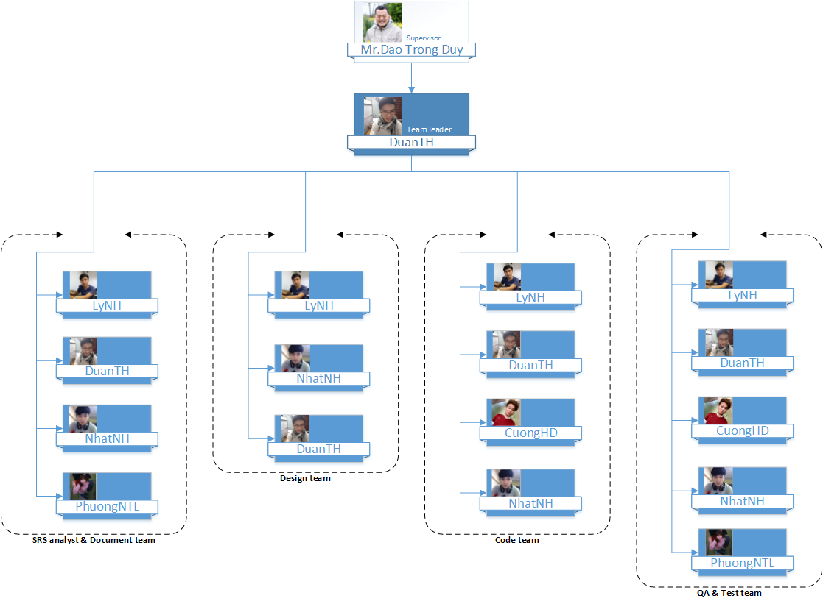

Figure ‑: Organization Structure

## Project Team

|  |  |  |  |  |  |
| --- | --- | --- | --- | --- | --- |
| Role | Responsibility | Full name | Effort (%) | Start date | End date |
| PM | Developing and maintaining a detailed project plan.  • Managing project deliverable in line with the project plan.  • Managing key point discuss with lecture by meeting minutes.  • Monitoring action plan.  • Managing project scope and change control and escalating issues where necessary.  • Monitoring project progress and performance  • Providing status reports to the Supervisor.  • Liaison with, and updates on progress to the Supervisor.  • Final approval of the design specification. | DuanTH | 100 | 05/09/2016 | 07/12/2016 |
| QA | - Design & review document | PhuongNTL | 100 | 05/09/2016 | 07/12/2016 |
| Programmer | - Study technique  - Coding functions and modules of system.  - Peer-review source code of others members | LyNH  DuanTH  CuongHD  NhatNH | 100 | 05/09/2016 | 07/12/2016 |
| Tester | - Create test plan, test case, test report, quality report  - Execute test. | PhuongNTL  DuanTH  LyNH  NhatNH  CuongHD | 100 | 05/09/2016 | 07/12/2016 |
| Designer | - Create screen design, prototype  - Review design of others member | LyNH  NhatNH  DuanTH | 100 | 05/09/2016 | 07/12/2016 |

Table 5‑1: Project Team

## External Interfaces

FPT University’s Interfaces:

|  |  |  |  |
| --- | --- | --- | --- |
| Department | Contact Person  (name-position) | Contact address  (email, telephone) | Responsibility |
| Teacher | Đào Trọng Duy | duydt@fpt.edu.vn | - Review and accept documents during project  - Review and accept products of the project.  - Resolve escalated issues and receive project reports. |
| Training Department |  | acad.hn@fpt.edu.vn | Management course of student |

Table 5‑2: External Interfaces

# COMMUNICATION & REPORTING

|  |  |  |  |  |
| --- | --- | --- | --- | --- |
| **Communication Type** | **Method / Tool** | **When** | **Information** | **Participants / Responsible** |
| **Project Task Tracking** | | | | |
| Task scheduling | MS Project Professional 2016 | At the beginning of every stage, and weekly  Refinement and rescheduling as necessary |  | PM |
| Task status reporting | Daily Report | Daily |  | Project Team Members |
| **Project Meeting** | | | | |
| Kick-off Meeting | Face to face | Initiation stage | Project introduction; Project plan review; Risk identification; stakeholders identify. | PM, Project Team Members |
| Project Progress Review Meetings | Face to face | Weekly and on event | Communicate project status  Communicate and resolve any open issue, risks, and changes  Discuss any suggested improvement | PM, Project Team Members |
| Milestone Meetings | Face to face | 5 days After the completion of stages: Definition, Solution & Construction | Project objective review, evaluate project performance (quality, schedule, effort), Causal analysis, update project plan for next stage | PM, Project Team Members, QA, Supervisor |
| Transfer/Sharing of project documentation/information | Tortoise Git | When available | All project documentation and information | PM, Project Team Members, QA |
| **Supervisor Communication and Reporting:** | | | | |
| Project Report | Agreed Fsoft and FU standard format | 5pm Monday, Weekly | Project status report, Issue requiring clarifications, escalation, if any | PM |
| Project Meetings with supervisor | Face to face | 16:10 Tuesday, Saturday | As above | PM |
| Requirement gathering/clarification | Face to face meeting | During requirement analysis phase | As in Q&A list | PM |
| **Communication with Supervisor** | | | | |
| Review Project Plan & Project schedule | By attend project meeting | Significant changes to WO, PP and Project schedule (scope, objectives Organization, HR, major milestone, deliverables) |  | PM |
| Project Progress Review | By email and/or via Operation meeting at Group/Division level | Weekly | Project status report, Issue requiring clarifications, escalation, if any | PM |
| Project Milestone Review | By email and via project milestone review meeting | End of every stage | Project objective review, evaluate project performance (quality, schedule, effort), Causal analysis, update project plan for next stage | PM |

Table 6‑1: Communication and Reporting

# CONFIGURATION MANAGEMENT

The detail configuration management is available in file:**HBS_CMPlan_v1.0_EN.docx**.